**CHANDIGARH UNIVERSITY**

**UNIVERSITY INSTITUTE OF ENGINEERING**

**DEPARTMENT OF COMPUTER SCIENCE & ENGINEERING**



|  |  |
| --- | --- |
| **Submitted By:** Sahil Kaundal  **Submitted To:** Neeru Sharma | |
| **Subject Name** | Programming Based Learning Java (Lab) |
| **Subject Code** | 20CSP-321 |
| **Branch** | Computer Science Engineering |
| **Semester** | 5th |

LAB INDEX

**NAME:** Sahil Kaundal **SUBJECT NAME:** PBLJ (Lab)

**UID:** 21BCS8197 **SUBJECT CODE:** 20CSP-321

**SECTION:** 20BCS_WM-616/A

|  |  |  |  |  |  |  |  |
| --- | --- | --- | --- | --- | --- | --- | --- |
| **Sr.No** | **Program** | **Date** | **Evaluation** | | | | **Sign** |
| **LW**  **(12)** | **VV**  **(10)** | **FW**  **(8)** | **Total**  **(30)** |
| 1. | Create an application to save the employee information using arrays. | 16/08/2022 |  |  |  |  |  |
| 2. | Design and implement a simple inventory control system for a small video rental store. | 20/08/2022 |  |  |  |  |  |
| 3. | Create a application to calculate interest for FDs, RDs based on certain conditions using inheritance. | 27/08/2022 |  |  |  |  |  |
|  |  |  |  |  |  |  |  |
|  |  |  |  |  |  |  |  |
|  |  |  |  |  |  |  |  |

**Experiment 3**

**Student Name:** Sahil Kaundal **UID:** 21BCS8197

**Branch:** BE CSE (Lateral Entry) **Section/Group:** 616/A

**Semester:** 5th **Date of Performance:** 27/08/2022

**Subject Name:** PBLJ Lab **Subject Code:** 20CSP-321

1. **Aim/Overview of the practical:**

Create an application to calculate interest for FDs, RDs based on certain conditions using inheritance.

1. **Apparatus / Simulator Used:**

* Eclipse IDE - (Java)
* NetBeans.

1. **Algorithm/Flowchart:**

* Make account class.
* Using method overriding create interest calculate.
* Create FD, Rd and SD.
* Take input of amount and age and days for FD.
* Take input of saving account and NRI and non NRI.
* For Rd take amount and month and age as input.
* Create a launcher class

1. **Programs/ Code:**

package Exp3;  
import java.util.Scanner;  
public class InterestCalculator {  
 public static void main(String[] args) {  
 Scanner sc = new Scanner(System.*in*);  
 System.*out*.println("SELECT THE OPTIONS " + "\n1." + " Interest Calculator-SB" + " \n2." + " Interest Calculator-FD" + "\n3." + " InterestCalculator-RD" + "\n4 " + " Exit");  
 int choice = sc.nextInt();  
 switch (choice) {

case 1:  
 SBaccount sb = new SBaccount();  
 try {  
 System.*out*.println("Enter the Average SB amount ");  
 double amount = sc.nextDouble();  
 System.*out*.println("Interest gained is : Rs " + sb.calculateInterest(amount));  
 } catch (InvalidAmountException e) {  
 System.*out*.println("Exception : Invalid amount");  
 }break;  
 case 2:  
 try {  
 FDaccount fd = new FDaccount();  
 System.*out*.println("Enter the FD Amount");  
 double fAmount = sc.nextDouble();  
 System.*out*.println("Interest gained is: Rs " + fd.calculateInterest(fAmount));  
 } catch (InvalidAgeException e) {  
 System.*out*.println("Invalid Age Entered");  
 } catch (InvalidAmountException e) {  
 System.*out*.println("Invalid Amount Entered");  
 } catch (InvalidDaysException e) {  
 System.*out*.println("Invalid Days Entered");  
 }break;  
 case 3:  
 try {  
 RDaccount rd = new RDaccount();  
 System.*out*.println("Enter the RD amount");  
 double Ramount = sc.nextDouble();  
 System.*out*.println("Interest gained is: Rs " + rd.calculateInterest(Ramount));  
 }  
 catch (InvalidAgeException e) {  
 System.*out*.println("Invalid Age Entered");  
 } catch (InvalidAmountException e) {  
 System.*out*.println("Invalid Amount Entered");  
 } catch (InvalidMonthsException e) {  
 System.*out*.println("Invalid Days Entered");  
 }break;  
 case 4:  
 System.*out*.println("DO YOU WANT TO CALCULATE AGAIN ????" + " "  
 + "RUN AGAIN THE PROGRAM");  
 default:  
 System.*out*.println("Wrong choice");}  
 sc.close(); }  
}abstract class Account {  
 double interestRate;  
 double amount;  
 abstract double calculateInterest(double amount)throws InvalidMonthsException,InvalidAgeException,InvalidAmountException ,InvalidDaysException;  
}class FDaccount extends Account {  
 double FDinterestRate;  
 double FDAmount;  
 int noOfDays;  
 int ageOfACHolder;  
 double General, SCitizen;  
 Scanner FDScanner = new Scanner(System.*in*);  
 double calculateInterest(double amount) throws InvalidAgeException,InvalidAmountException,InvalidDaysException {  
 this.FDAmount = amount;  
 System.*out*.println("Enter FD days");  
 noOfDays = FDScanner.nextInt();  
 System.*out*.println("Enter FD age holder ");  
 ageOfACHolder = FDScanner.nextInt();  
 if (amount < 0) {  
 throw new InvalidAmountException();  
 }  
 if(noOfDays<0){  
 throw new InvalidDaysException();  
 }  
 if(ageOfACHolder<0){  
 throw new InvalidAgeException();  
 }  
 if (amount < 10000000) {  
 if (noOfDays >= 7 && noOfDays <= 14) {  
 General = 0.0450;  
 SCitizen = 0.0500; }  
 else if (noOfDays >= 15 && noOfDays <= 29) {  
 General = 0.0470;  
 SCitizen = 0.0525;  
 } else if (noOfDays >= 30 && noOfDays <= 45) {  
 General = 0.0550;  
 SCitizen = 0.0600;  
 } else if (noOfDays >= 45 && noOfDays <= 60) {  
 General = 0.0700;  
 SCitizen = 0.0750;  
 } else if (noOfDays >= 61 && noOfDays <= 184) {  
 General = 0.0750;  
 SCitizen = 0.0800;  
 } else if (noOfDays >= 185 && noOfDays <= 365) {  
 General = 0.0800;  
 SCitizen = 0.0850;  
 }  
 FDinterestRate = (ageOfACHolder < 50) ? General : SCitizen;  
 } else {  
 if (noOfDays >= 7 && noOfDays <= 14) {  
 interestRate = 0.065;  
 } else if (noOfDays >= 15 && noOfDays <= 29) {  
 interestRate = 0.0675;  
 } else if (noOfDays >= 30 && noOfDays <= 45) {  
 interestRate = 0.00675;  
 } else if (noOfDays >= 45 && noOfDays <= 60) {  
 interestRate = 0.080;  
 } else if (noOfDays >= 61 && noOfDays <= 184) {  
 interestRate = 0.0850;  
 } else if (noOfDays >= 185 && noOfDays <= 365) {  
 interestRate = 0.10;  
 }}  
 return FDAmount * FDinterestRate; }  
}  
class InvalidAgeException extends Exception{}  
  
class InvalidAmountException extends Exception{}  
  
class InvalidDaysException extends Exception{}  
  
class InvalidMonthsException extends Exception{}  
  
class RDaccount extends Account {  
 double RDInterestRate;  
 double RDamount;  
 int noOfMonths;  
 double monthlyAmount;  
 double General, SCitizen;  
 Scanner RDScanner = new Scanner(System.*in*);  
 double calculateInterest(double Ramount) throws InvalidMonthsException,InvalidAmountException ,InvalidAgeException {  
 this.RDamount = Ramount;  
 System.*out*.println("Enter RD months");  
 noOfMonths = RDScanner.nextInt();  
 System.*out*.println("Enter RD holder age");  
 int age = RDScanner.nextInt();  
 if (RDamount < 0) {  
 throw new InvalidAmountException();  
 }  
 if(noOfMonths<0){  
 throw new InvalidMonthsException();  
 }  
 if(age<0){  
 throw new InvalidAgeException();  
 }  
 if (noOfMonths >= 0 && noOfMonths <= 6) {  
 General = .0750;  
 SCitizen = 0.080;  
 } else if (noOfMonths >= 7 && noOfMonths <= 9) {  
 General = .0775;  
 SCitizen = 0.0825;  
 } else if (noOfMonths >= 10 && noOfMonths <= 12) {  
 General = .0800;  
 SCitizen = 0.0850;  
 } else if (noOfMonths >= 13 && noOfMonths <= 15) {  
 General = .0825;  
 SCitizen = 0.0875;  
 } else if (noOfMonths >= 16 && noOfMonths <= 18) {  
 General = .0850;  
 SCitizen = 0.0900;  
 } else if (noOfMonths >= 22) {  
 General = .0875;  
 SCitizen = 0.0925;  
 }  
 RDInterestRate = (age < 50) ? General : SCitizen;  
 return RDamount * RDInterestRate; }  
}  
class SBaccount extends Account {  
 double SBamount , SbInterestRate, interest;  
 Scanner SBScanner = new Scanner(System.*in*);  
 double calculateInterest(double amount) throws InvalidAmountException{  
 this.SBamount = amount;  
 if(SBamount < 0 ){  
 throw new InvalidAmountException(); }  
 System.*out*.println("Select account type \n1. NRI \n2. Normal ");  
 int accountChoice = SBScanner.nextInt();  
 switch (accountChoice) {  
 case 1:  
 SbInterestRate = .06;  
 break;  
 case 2:  
 SbInterestRate = .04;  
 break;  
 default:  
 System.*out*.println("Please choose right account again");

}  
 return amount * SbInterestRate;  
 }}

**5. Result/Output/Writing Summary:**

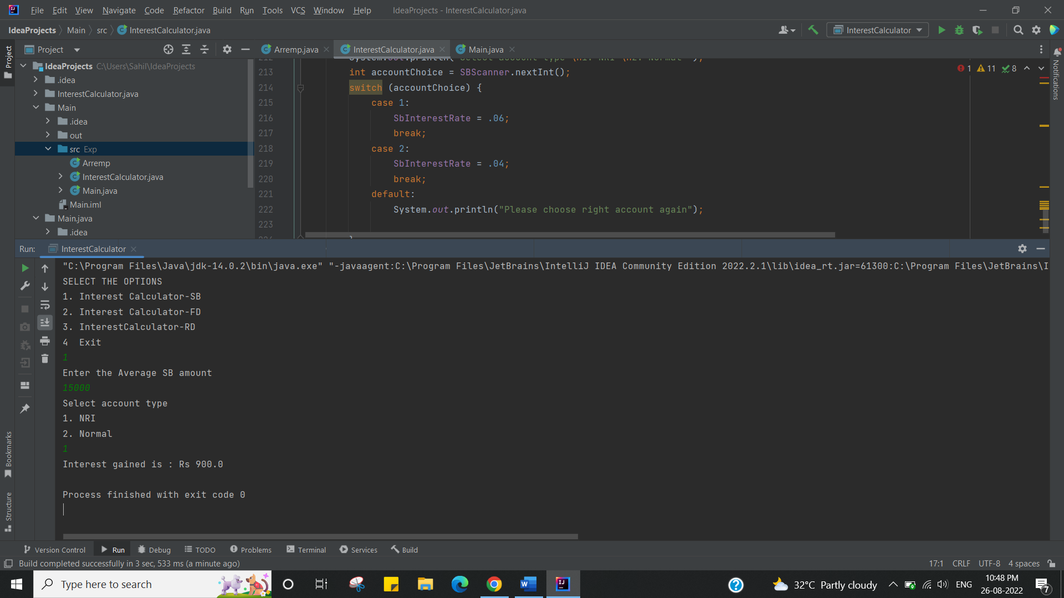

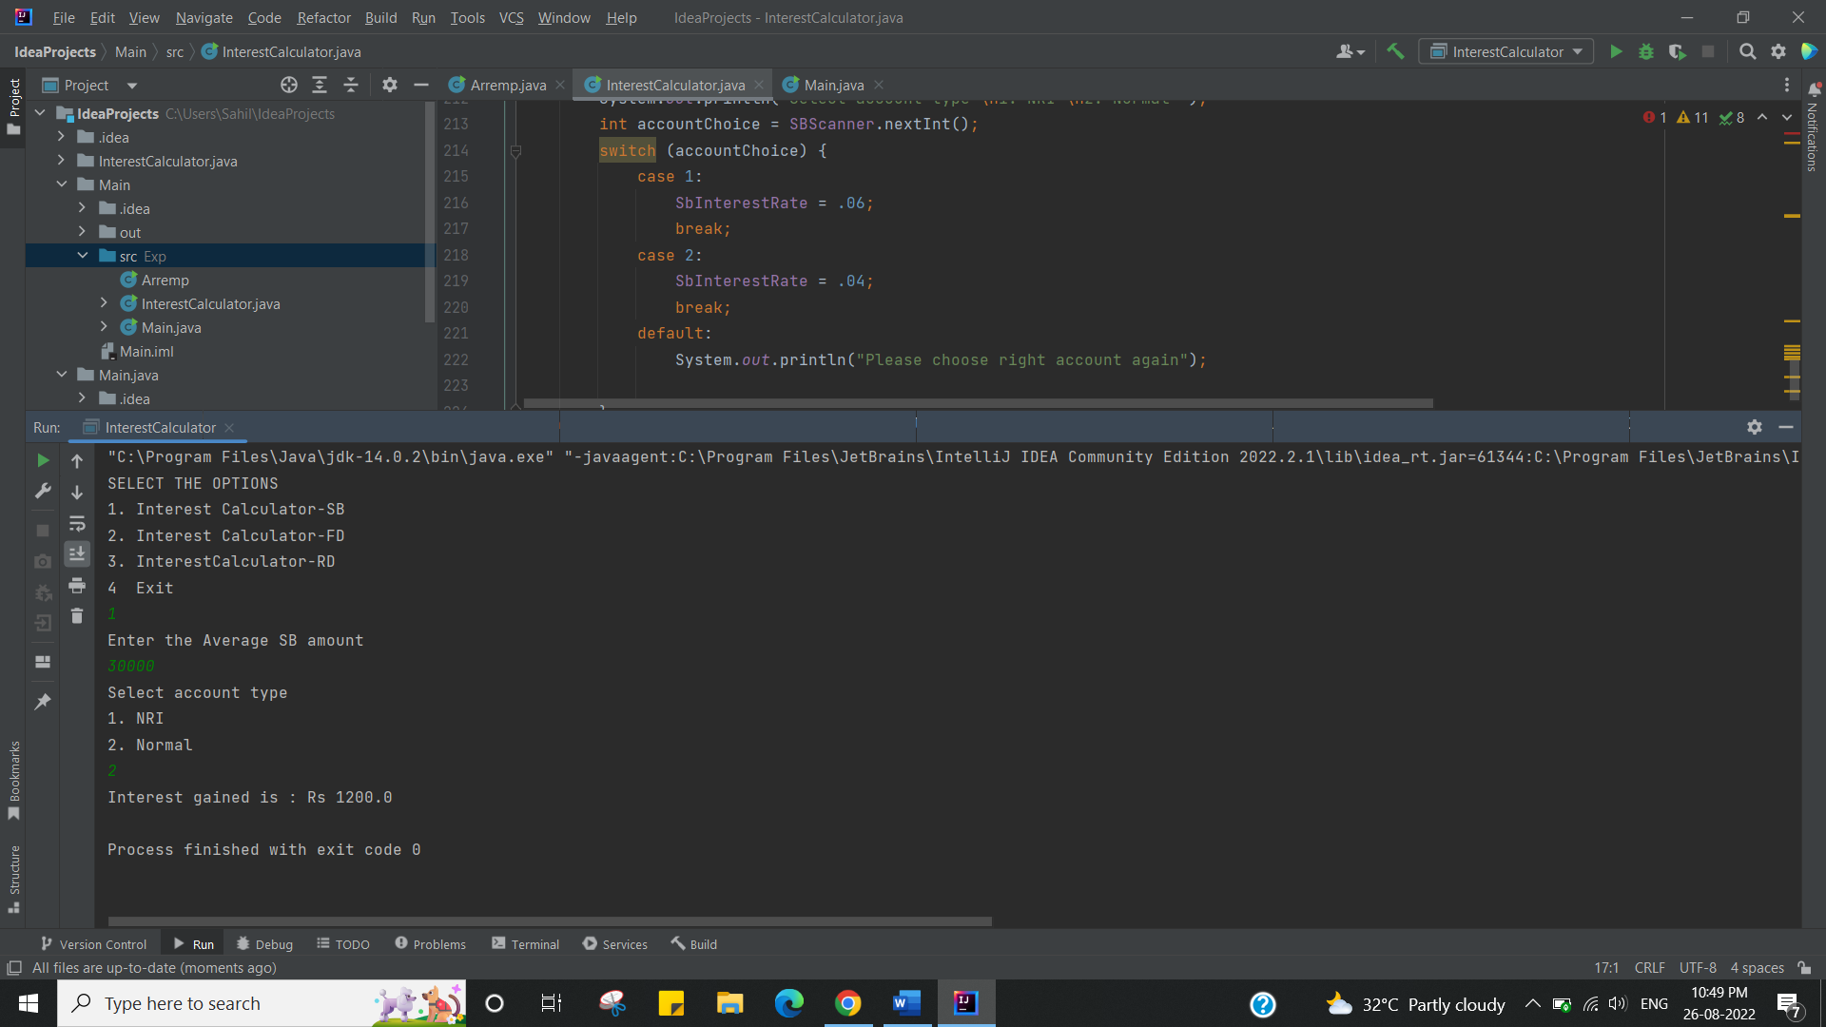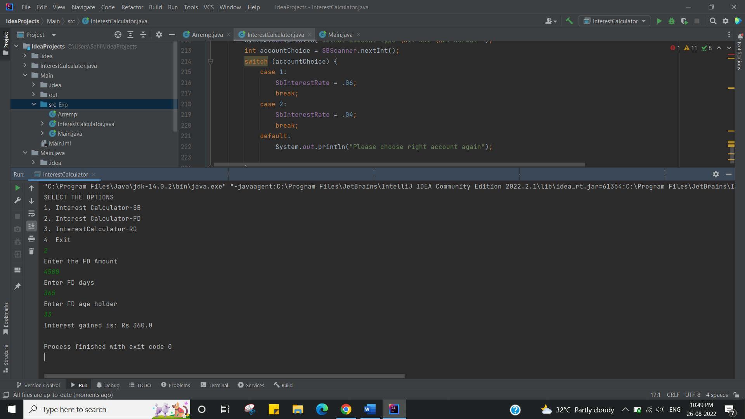

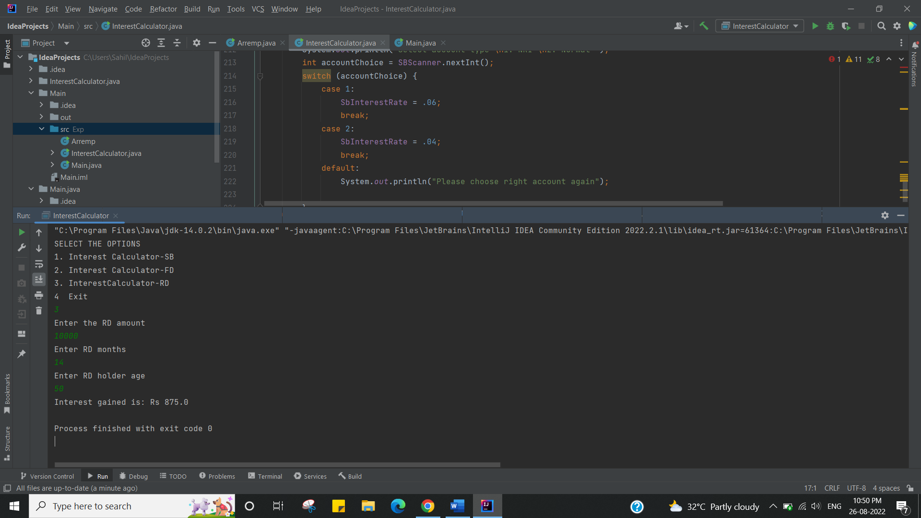

I have successfully done this program.

**Learning Outcomes (What I have learnt):**

1. Here we have learnt the Concept of Inheritance with the Abstract class
2. And finding the Interest, SB, RD & FD based on the Amount, Citizenship and Age group.

**Evaluation Grid (To be created as per the SOP and Assessment guidelines by the faculty):**

|  |  |  |  |
| --- | --- | --- | --- |
| Sr. No. | Parameters | Marks Obtained | Maximum Marks |
| 1. |  |  |  |
| 2. |  |  |  |
| 3. |  |  |  |